# CS 255 System Design Document

Brent Artuch

CS-255-T3297

02/11/2023

## UML Diagrams

### UML Use Case Diagram

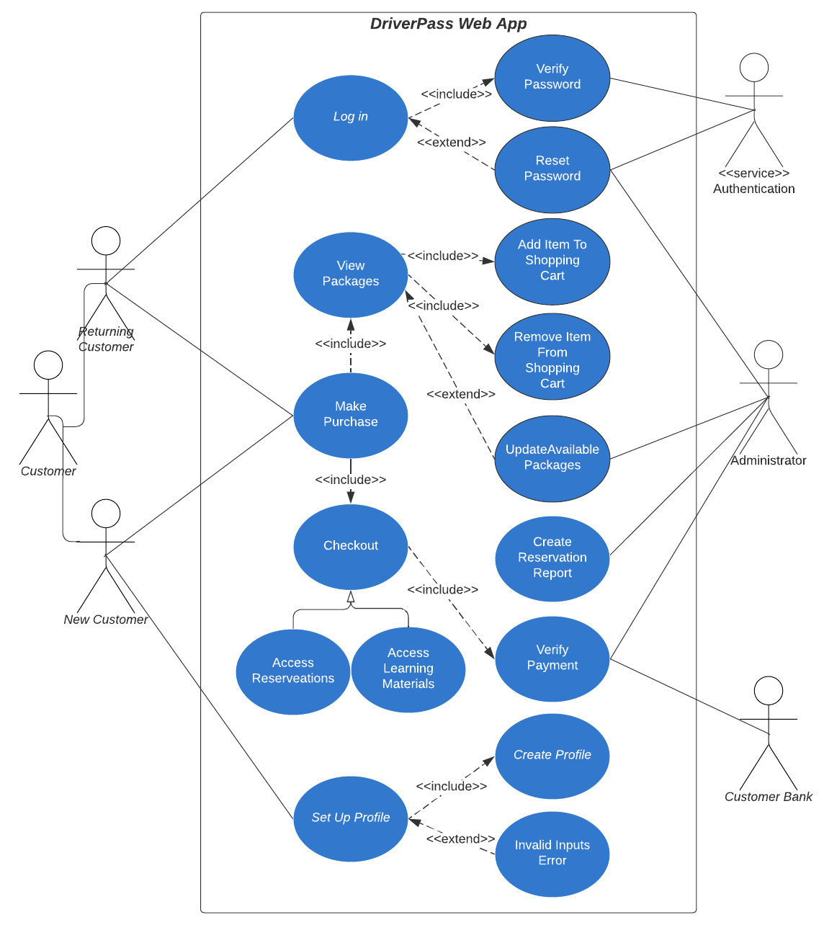

### UML Activity Diagrams

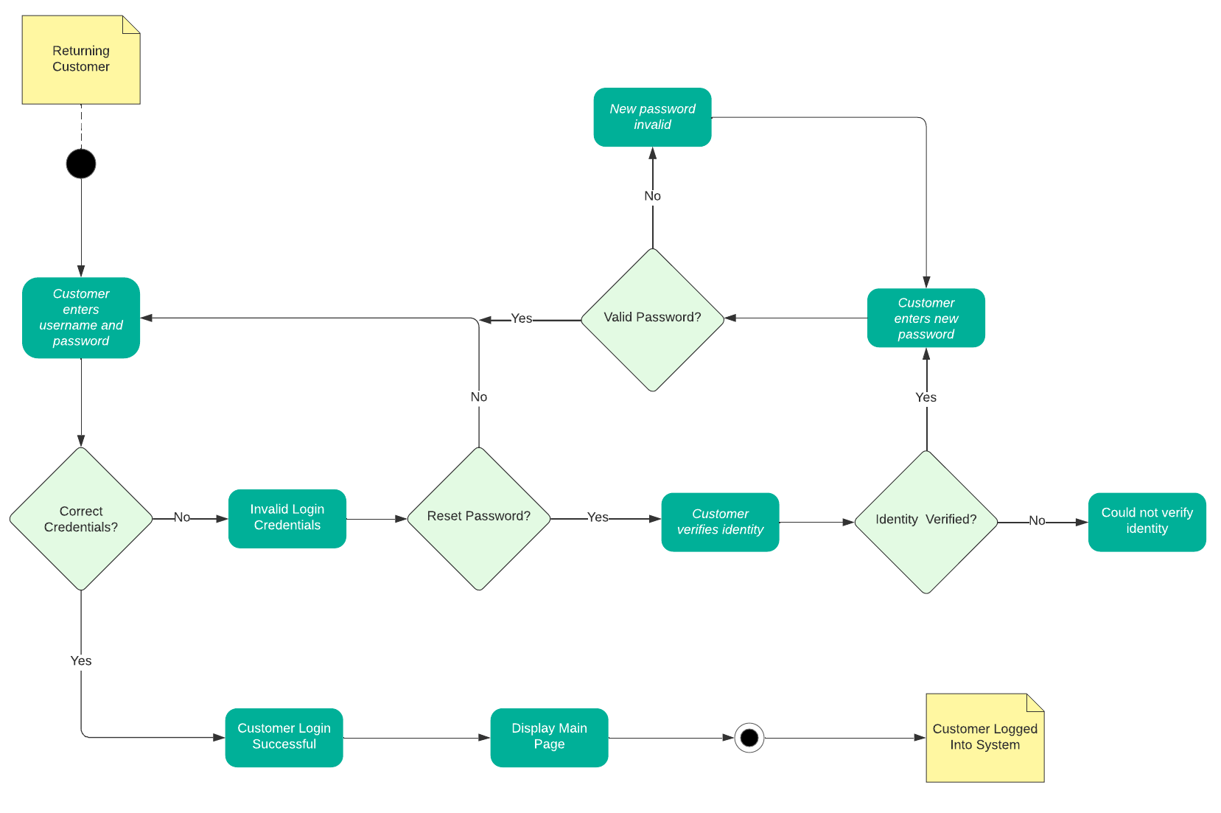

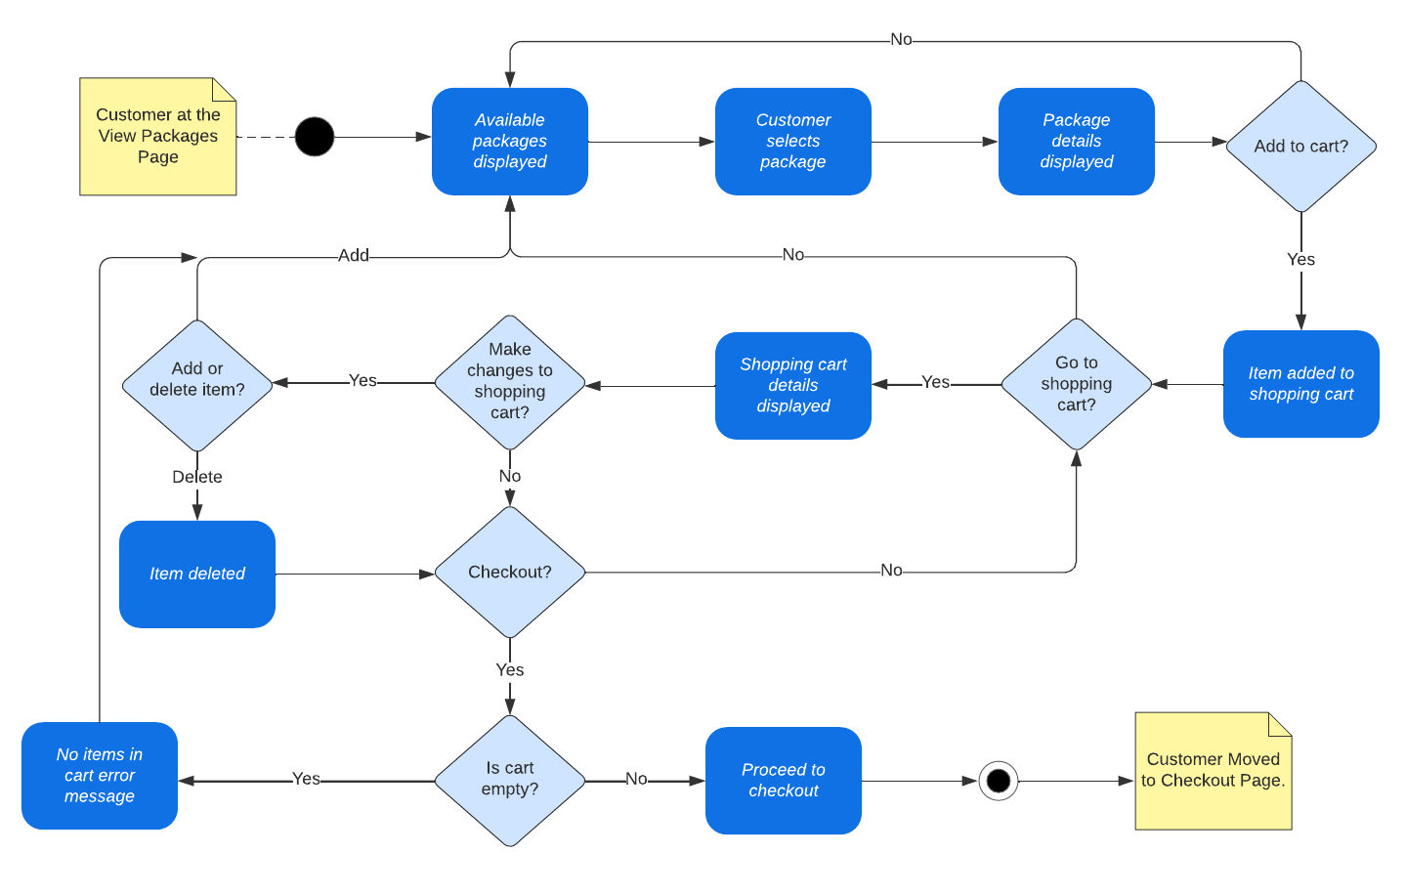

### UML Sequence Diagram

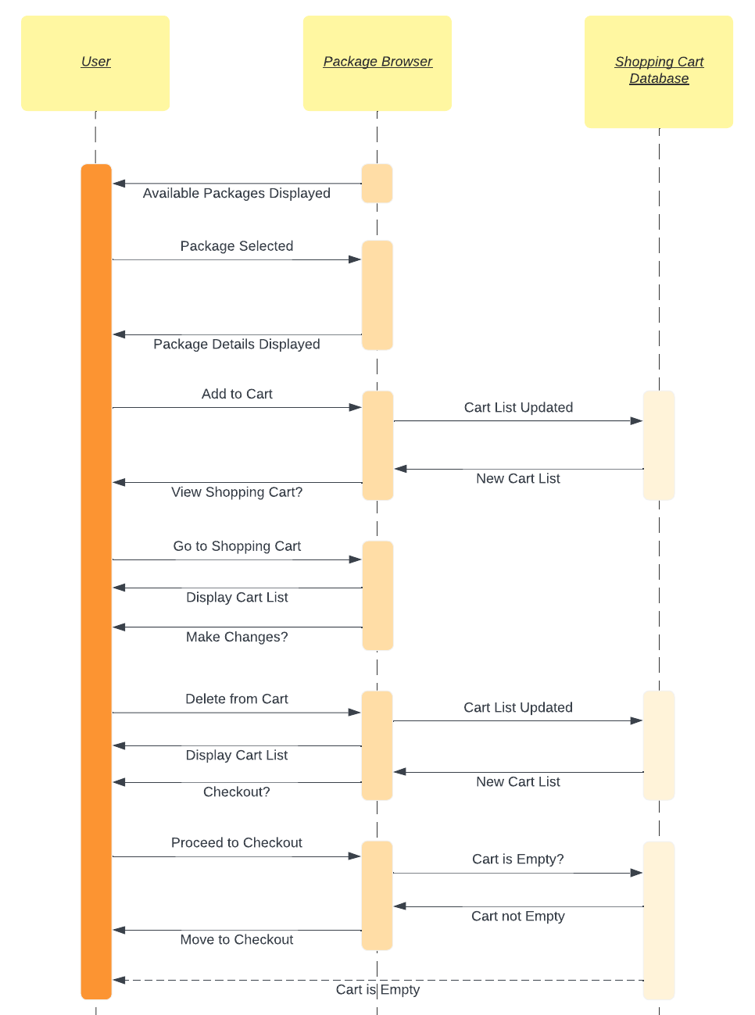

### UML Class Diagram

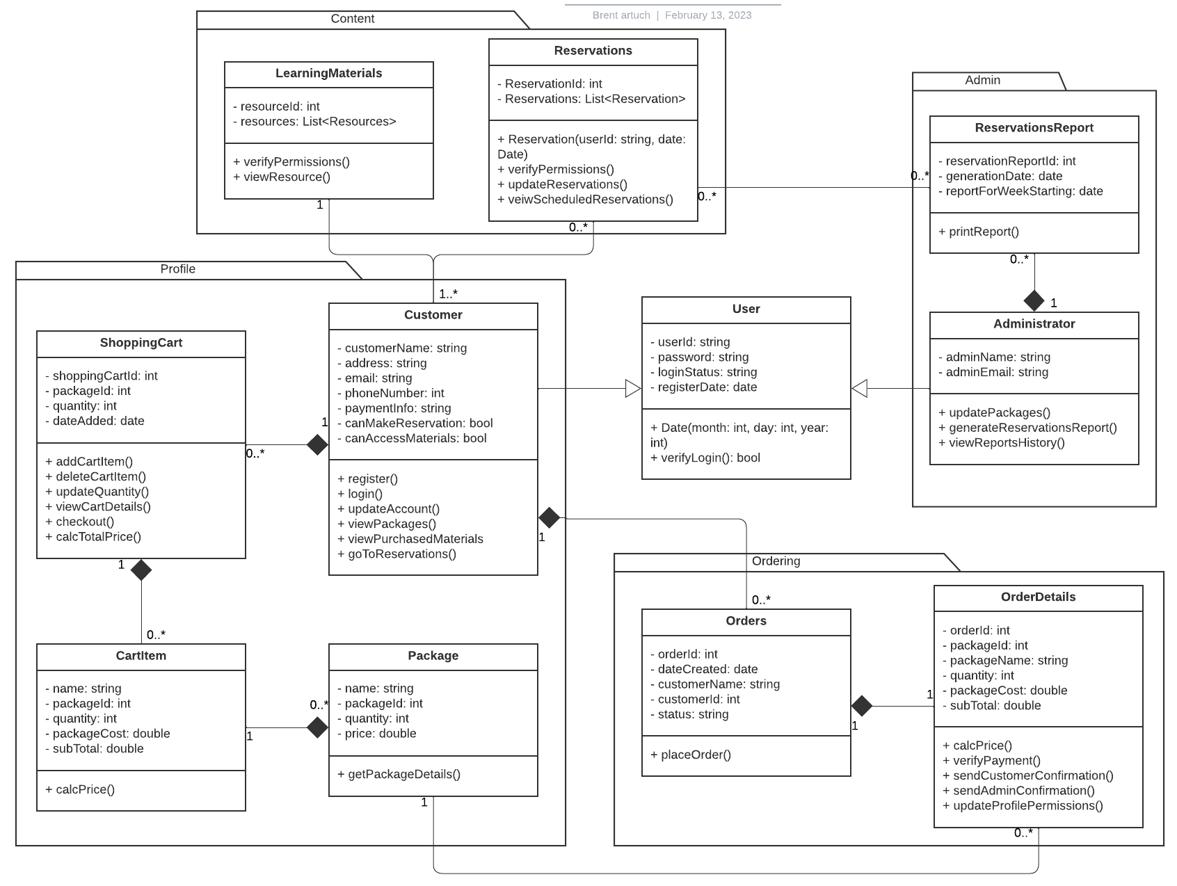

## Technical Requirements

* Authentication service for secure login process.  
    
  Will utilize authentication services such as Firebase authenticator so users can create accounts that will be stored in the system. The authenticator can be managed by the DriverPass administrators to determine privileges for users through the Firebase console.
* Realtime cloud database storage.   
    
  DriverPass expressed a desire to utilize cloud storage for security and auto scalability. The Firebase realtime database by Google would be a great solution for this in tandem with the authenticator so it can all be managed from one place. Shopping cart, reservation, and order data can all be stored and accessed through this database.
* Easy-to-use interface.  
    
  Create a non-cluttered interface that begins at the login page then directs the user to the main page illustrated by the DriverPass team. The checkout process should be quick and easy, and the purchased learning materials should be easily accessible.
* Mobile friendly web application layout.  
    
  As it relates to portability, the web application layout should be adaptable to a multitude of various devices. So the different views of the web page need to be well constrained and scrollable to adjust to various device screen dimensions.
* Security measures.  
    
  Implement encryption to user stored payment data to ensure that identity theft is prevented as well as use of encrypted connections that have alerts in place to flag malicious activity throughout the system.
* RESTful web development API.  
    
  Utilize Java and Maven to create the web application which will be portable across multiple devices and web browsers via HTTP requests. Implement JSON API to further integrate the system with the Google Cloud services.
* Programming language: Java  
    
  Java is highly portable and proficient in terms of memory management through features such as first fit allocation and garbage collection.
* Development system: MacOS  
    
  Is a great all around system as it relates to hardware and efficient processing. Included tools such as Activity Monitor and assist in improving application efficiency at runtime and the ability to develop in the Swift programming language could prove useful in the future should DrivePass elect to incorporate a dedicated iOS application.